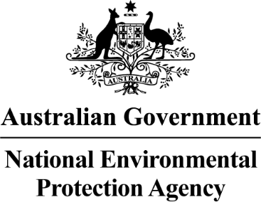
APPLICATION FOR A NATIONAL
REFRIGERANT HANDLING LICENCE
Supervisor Declaration
ARCtick Licence No. Date
/ /
L
Applicant Details
First Name

Last Name
/ /
Date of Birth

Supervisor Details

Supervisor Name |  |  | ARCtick Licence No. L
Employer's Name
Business Address
State | Postcode | RTA Permit No. AU |  | ABN

Supervisor Declaration – to be completed by the supervisor above
For this Trainee Licence to be issued, the supervisor’s declaration must be provided.
I confirm that I am currently working with the aforementioned applicant at the workplace listed above, and I have been nominated to supervise them while they undertake the following:
Course Code
Full Course Title
I declare that I have read and understand my obligations under the Ozone Protection and Synthetic Greenhouse Gas Management Regulations 1995.

By signing this declaration, I acknowledge and confirm the following:
- A trainee is entitled to carry out work in relation to Refrigeration and Air Conditioning (RAC) equipment while undertaking the training or assessment for which the licence was granted.
- This work must be performed under the supervision of a licence holder who is entitled to engage in the same scope of work for which the trainee is being trained or assessed.
- Work in relation to RAC equipment includes any activity involving a refrigerant that carries a risk of emission.
- I am responsible for ensuring that any work carried out by the trainee licensee is performed in accordance with the standards set out in Table 135, Column 2 that relate to the work.

Signature of Supervisor Signature of Witness (aged 18 years or over; must not be the applicant)
Date Date Name of Witness

/ /

/ /

